Q1(a). Install Node.js and create a basic HTTP server using the built-in http module.
1. Setting Up a Node.js Server
Topic: Install Node.js and create a basic HTTP server using the built-in http module.
What is Node.js?
Node.js is a runtime environment that allows you to run JavaScript outside the browser (on the server).
Why use Node.js?
- Fast
- Lightweight
- Good for real-time apps
- Uses JavaScript everywhere (frontend + backend)
Steps to Set Up a Node.js Server
Step 1: Install Node.js
- Go to https://nodejs.org
- Download LTS version
- Install by clicking Next → Next → Finish
- Check version:
node -v
npm -v
Step 2: Create a Project Folder
Example:
FSD/
Inside it, create a file:
Q1>
server.js

Step 3: Write Basic HTTP Server Using http Module
// Importing the 'http' module that allows us to create a web server
const http = require('http');
// Creating the server
// req = request (data coming from browser)
// res = response (data we send back to browser)
const server = http.createServer((req, res) => {
// Setting the response headers
// 200 = OK (successful response)
// 'Content-Type': 'text/plain' means we are sending plain text
res.writeHead(200, {'Content-Type': 'text/plain'});
// Sending the response message to the browser
res.end('Hello, this is my first Node.js Server!');
});
// Making the server listen on port 3000
server.listen(3000, () => {

// Message printed in the terminal to tell server is running
console.log('Server is running on http://localhost:3000');
});

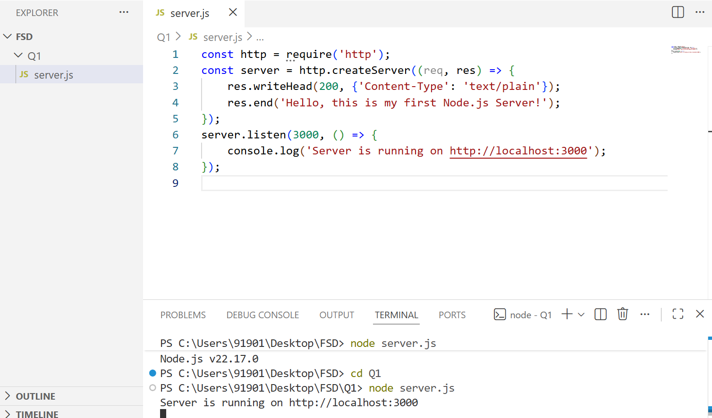
Open any Browser and type and search http://localhost:3000

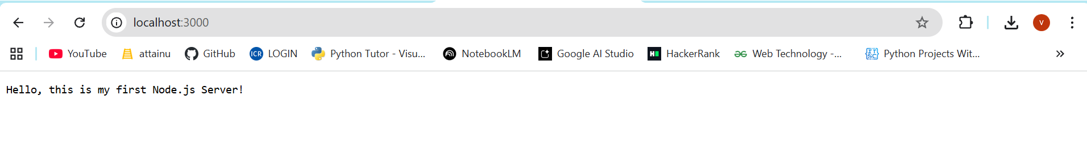

Q1(b) Experiment: Routing and Handling HTTP Methods (GET, POST, PUT, DELETE) in Node.js
(using only the built-in http module — no Express)

What is Routing?
Routing means deciding what response to give based on the URL the user requests.
Example:
- / → Home page
- /about → About page
- /contact → Contact page

What are HTTP Methods?
These are different types of requests sent by the client:
Method | Meaning | Example
GET | Only to fetch data | Open website
POST | Send data to server | Login form
PUT | Update data | Edit profile
DELETE | Delete data | Remove product

2. Sample Code (Simple Routing + GET & POST)
Create file server.js:
// Importing required modules
const http = require("http"); // To create the server
const fs = require("fs"); // To read files (like HTML files)
const path = require("path"); // To manage file paths

// Create the server
const server = http.createServer((req, res) => {

// By default, send JSON response
res.setHeader("Content-Type", "application/json");

// ------------------ ROUTE: HOME PAGE ------------------
// If user opens http://localhost:3000/
if (req.url === "/" && req.method === "GET") {
res.end(JSON.stringify({ message: "Home Page" })); // Send JSON
}

// ------------------ ROUTE: ABOUT PAGE ------------------
// If user opens http://localhost:3000/about
else if (req.url === "/about" && req.method === "GET") {
res.end(JSON.stringify({ message: "About Page" })); // Send JSON
}

// ------------------ ROUTE: SERVE LOGIN HTML PAGE ------------------
// If user opens http://localhost:3000/login (GET request)
else if (req.url === "/login" && req.method === "GET") {

// Path to login.html file in same folder
const filePath = path.join(__dirname, "login.html");

// Read login.html file
fs.readFile(filePath, "utf8", (err, data) => {

// If file not found or error occurs
if (err) {
res.statusCode = 500; // Server error
return res.end(JSON.stringify({ message: "File not found" }));
}

// If file found, send HTML instead of JSON
res.setHeader("Content-Type", "text/html");
res.end(data); // Send the HTML page
});
}

// ------------------ ROUTE: LOGIN FORM SUBMIT (POST REQUEST) ------------------
// When user submits login form
else if (req.url === "/login" && req.method === "POST") {

let body = ""; // To store incoming form data

// Collect chunks of form data
req.on("data", chunk => {
body += chunk;
});

// When all data is received
req.on("end", () => {

// Convert form data (username=vijay&password=1234)
const params = new URLSearchParams(body);

// Extract values from form
const data = {
username: params.get("username"),
password: params.get("password")
};

// Send response back to browser
res.end(JSON.stringify({
message: "Login Successful",
receivedData: data
}));
});
}

// ------------------ DEFAULT ROUTE ------------------
// If route not found
else {
res.statusCode = 404; // Not found error
res.end(JSON.stringify({ message: "Page Not Found" }));
}
});

// Start the server on port 3000
server.listen(3000, () => {
console.log("Server running at http://localhost:3000");
});

In Same folder Create login.html file

<!DOCTYPE html>
<html>
<body>

<h3>Login Form</h3>

<form action="http://localhost:3000/login" method="POST">
<input type="text" name="username" placeholder="Enter username"><br><br>
<input type="password" name="password" placeholder="Enter password"><br><br>
<button type="submit">Login</button>
</form>

</body>
</html>

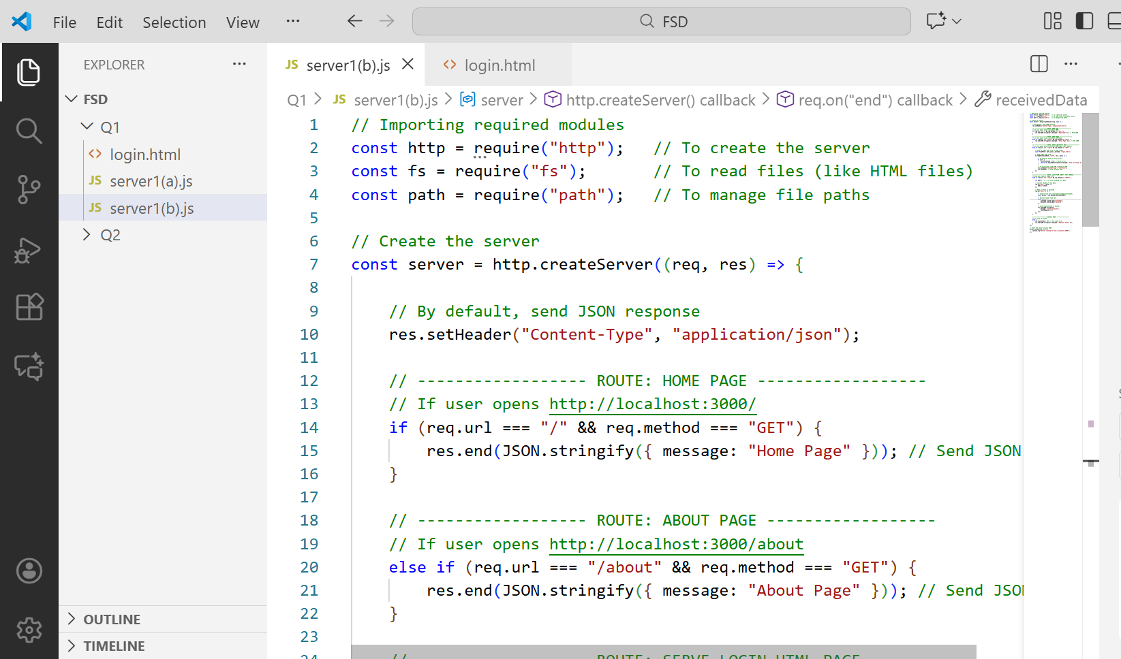
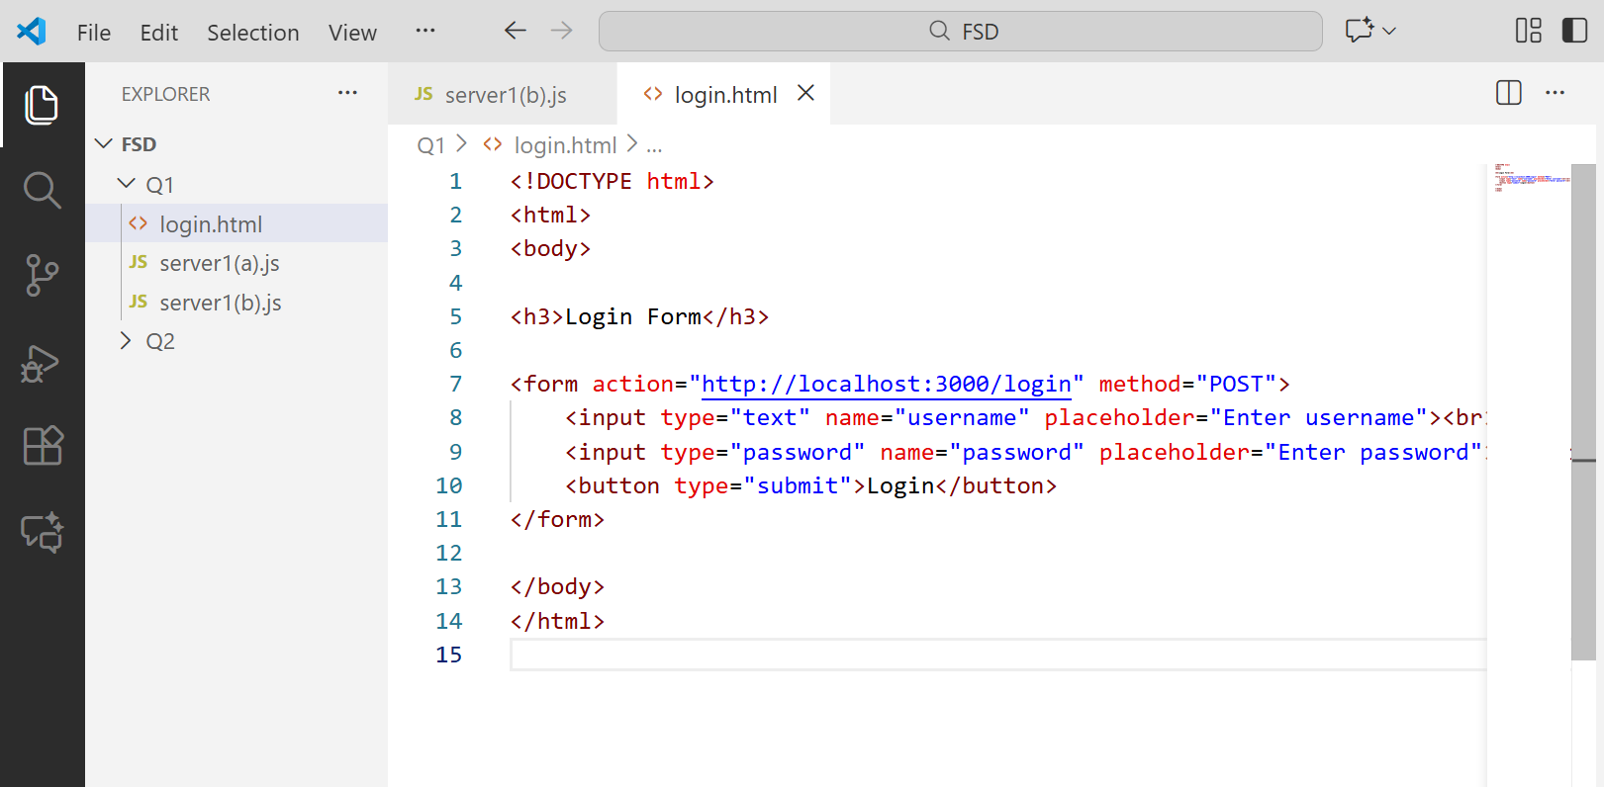
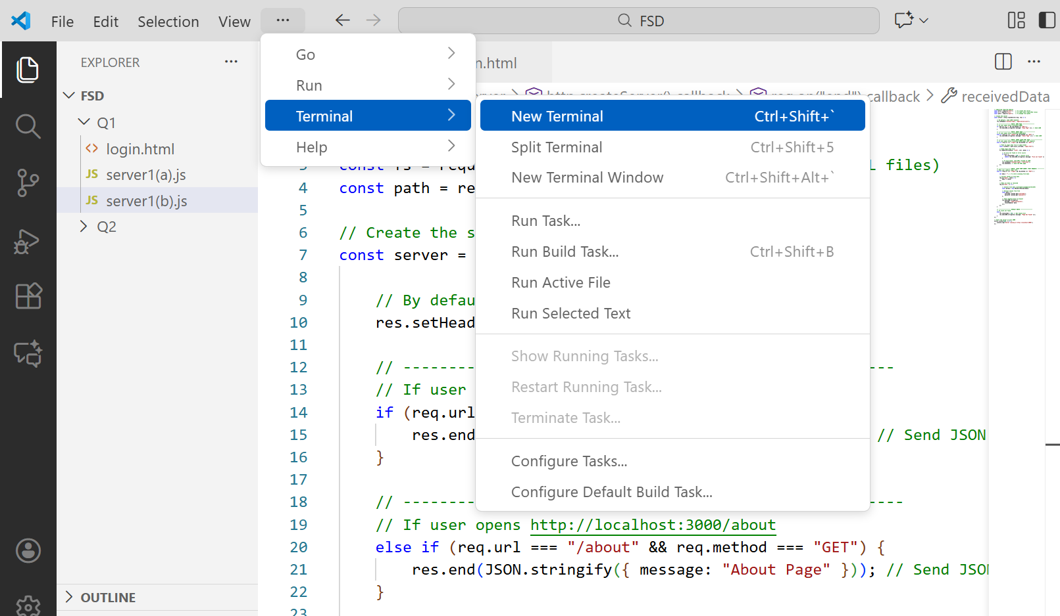
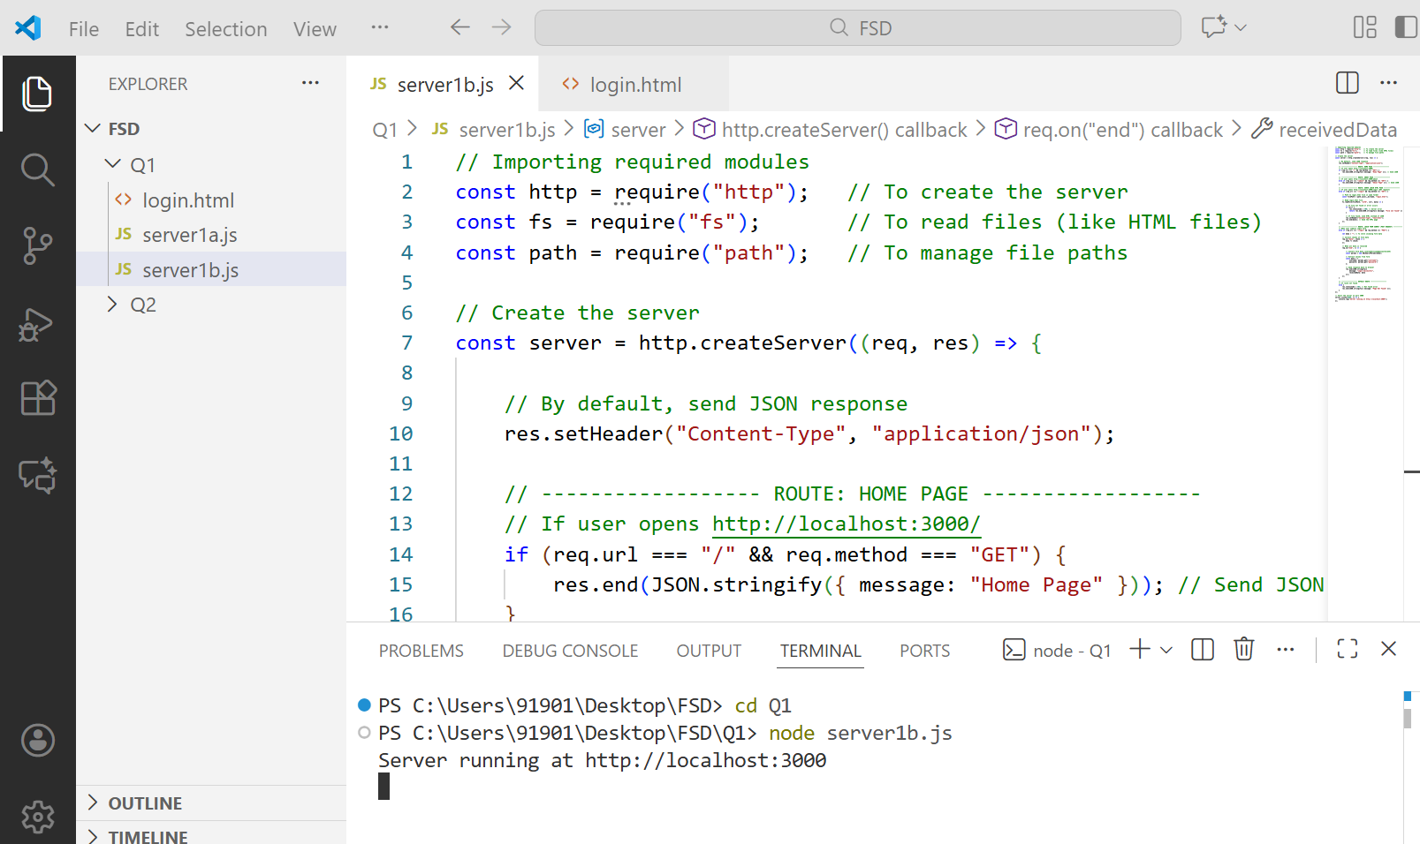
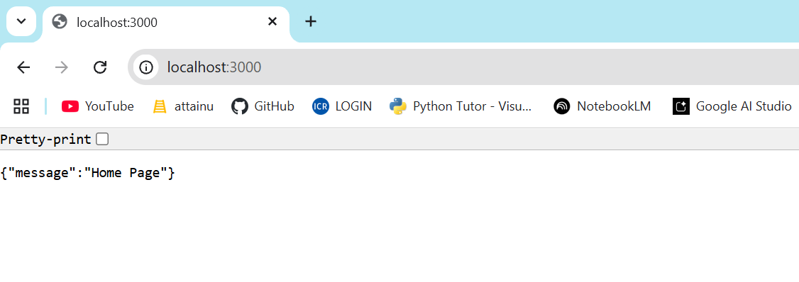
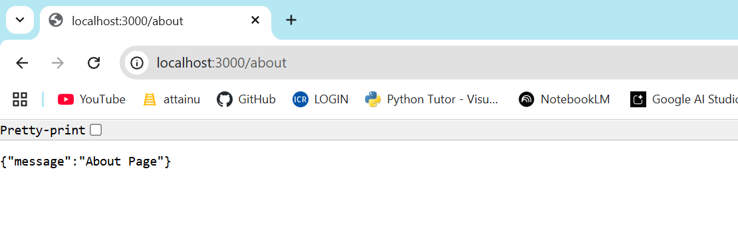
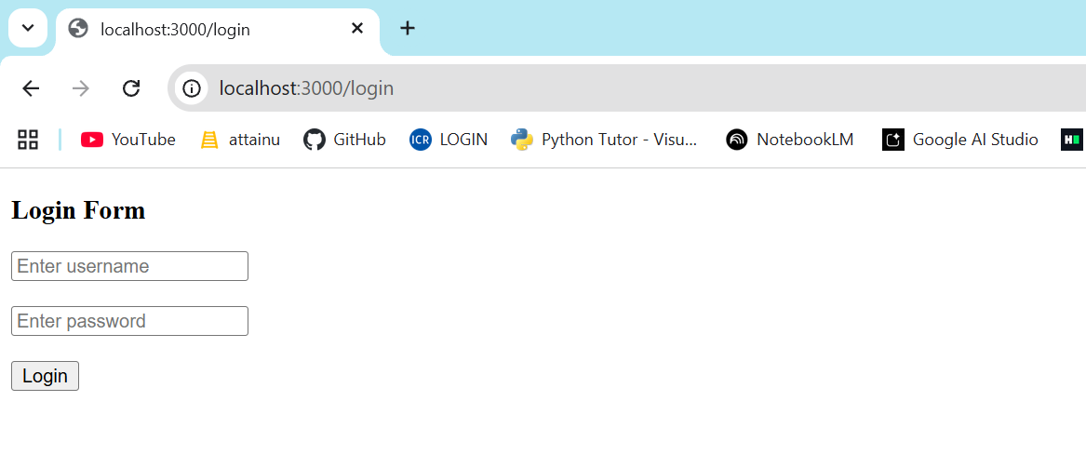
After given user name and password Enter Login the we will get
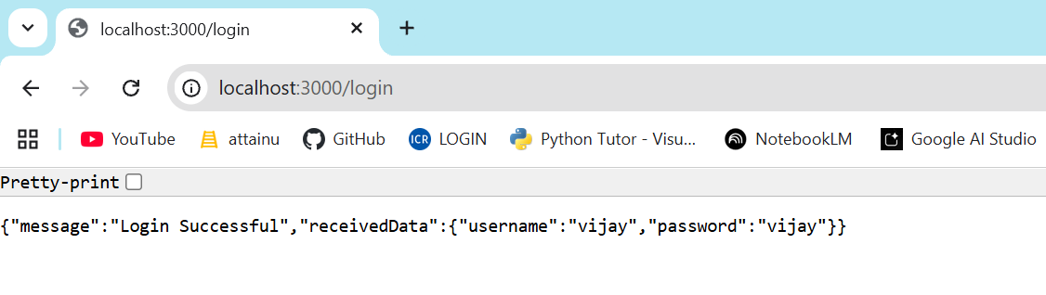

Q2. Using Express.js (CRUD Operations)
- Create a server using Express.js
- Implement CRUD: Create, Read, Update, Delete

1. What is Express.js (Easy Explanation)
Express.js is a framework for Node.js.
It makes server creation very easy compared to raw http module.
Benefits:
- Simple routing
- Cleaner code
- Built-in middleware
- Easy to build APIs (backend apps)

File Structure or Format
Q2/  │  ├── server.js  │  └── public/  ├── index.html  ├── delete.html  ├── add.html  ├── update.html | 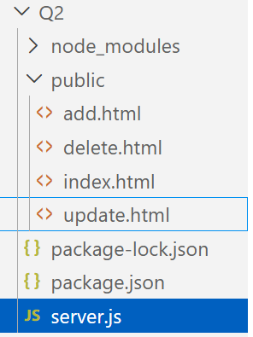

3. Create File: server.js (Express CRUD API)
Here is the complete CRUD code:

server.js

const express = require('express');
const app = express();
app.use(express.json()); // To read JSON data
app.use(express.static("public")); // To serve HTML/CSS/JS files

// Dummy users data
let users = [
{ id: 1, name: "Vijay" },
{ id: 2, name: "Babu" }
];

// ---------------- READ (GET) ----------------
app.get('/users', (req, res) => {
res.json(users);
});

// ---------------- CREATE (POST) ----------------
app.post('/users', (req, res) => {
const newUser = req.body; // Read new user
users.push(newUser); // Add to array
res.json({ message: "User added", users });
});

// ---------------- UPDATE (PUT) ----------------
app.put('/users/:id', (req, res) => {
const id = parseInt(req.params.id);
const updatedUser = req.body;

users = users.map(u =>
u.id === id ? { ...u, ...updatedUser } : u
);

res.json({ message: "User updated", users });
});

// ---------------- DELETE (DELETE) ----------------
app.delete('/users/:id', (req, res) => {
const id = parseInt(req.params.id);
users = users.filter(u => u.id !== id);
res.json({ message: "User deleted", users });
});

// Start server
app.listen(3000, () => {
console.log("Server running at http://localhost:3000");
});

public/index.html

<!DOCTYPE html>
<html>
<head>
<title>Users List</title>
</head>
<body>
<h1>All Users</h1>

<a href="add.html">Add User</a><br>
<a href="update.html">Update User</a><br>
<a href="delete.html">Delete User</a><br><br>

<div id="users"></div>

<script>
fetch('/api/users')
.then(res => res.json())
.then(data => {
document.getElementById("users").innerHTML =
data.map(u => `<p>${u.id}. ${u.name}</p>`).join("");
});
</script>
</body>
</html>

Public/add.html

<!DOCTYPE html>
<html>
<head><title>Add User</title></head>
<body>
<h1>Add User</h1>
<form action="/api/users" method="POST">
Name: <input type="text" name="name">
<button type="submit">Add</button>
</form>

<a href="index.html">Back</a>
</body>
</html>

Public/delete.html

<!DOCTYPE html>
<html>
<head><title>Delete User</title></head>
<body>
<h1>Delete User</h1>
<form action="/api/delete" method="POST">
User ID: <input type="number" name="id"><br><br>
<button type="submit">Delete</button>
</form>
<a href="index.html">Back</a>
</body>
</html>

Public/update.html

<!DOCTYPE html>
<html>
<head><title>Update User</title></head>
<body>
<h1>Update User</h1>
<form action="/api/update" method="POST">
User ID: <input type="number" name="id"><br><br>
New Name: <input type="text" name="name"><br><br>
<button type="submit">Update</button>
</form>
<a href="index.html">Back</a>
</body>
</html>
How to Run
- Create Q2 folder
- Inside it create server.js
- Make public folder → add the 4 HTML files
- Install Express:
npm install express
- Run server:
node server.js
- Open browser:
http://localhost:3000/index.html

What You Learned ?
You now understand:
Express.js
CRUD operations
HTML forms
Serving static files
Simple routing
Using POST for Create/Update/Delete
